FACULTY EVALUATION
Programme Name: SBVP ALUMNI MASTERCLASS Online s Module 2 Zambia (4th May 2026 - 8th May 2026)
Session: Long-term sustainability planning
Faculty Name: Kingsley Kalusha
No. of Respondents: 11
No. of Participants: 11
Evaluation Parameter | (%) Individual Score | (%) Programme Average
Punctuality (Commencement and Completion of Sessions) | 96 | 95
How well do you understand the core concepts presented? | 87 | 88
Rate your confidence in applying the new skills learnt | 91 | 85
Degree of Faculty preparedness for the sessions | 91 | 93
Content and methodology of the program | 93 | 95
Quality of class and group discussions | 91 | 91
The information presented in the course is relevant to my work (ministry) | 95 | 95
Average scores | 92 | 92

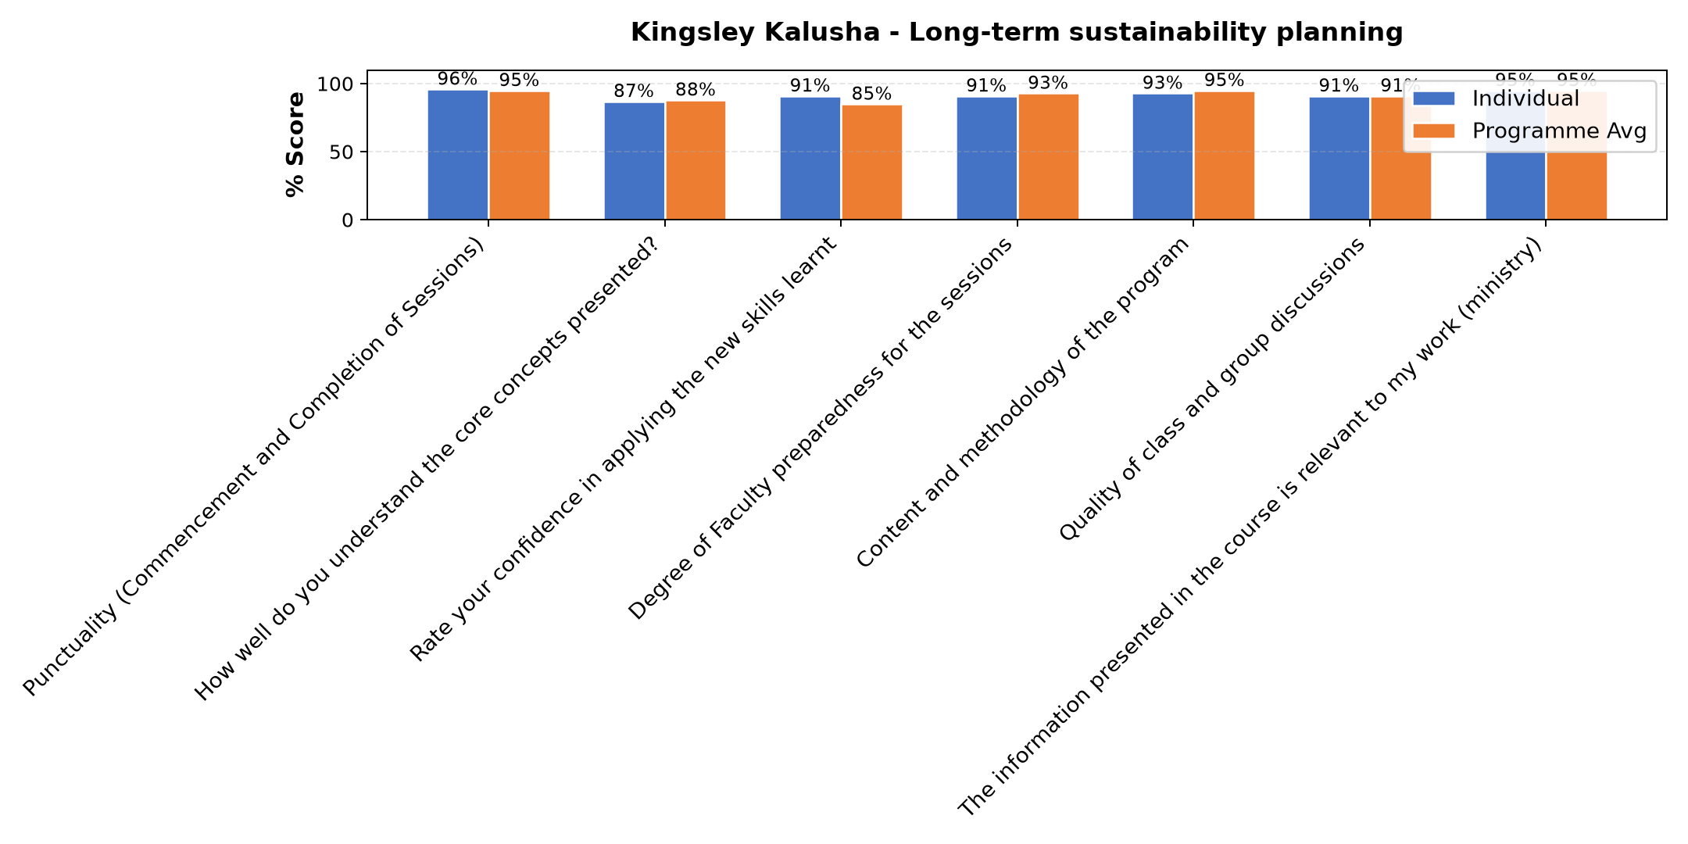

Comments & Feedback
- • Finance to source the demand of the parents because some come from far and transport is difficult for them as a result they prefer to withdraw their children and take them to other near by schools
- • No barriers will prevent me from applying what I have learnt
- • Financial problems
- • We always have Internet network problems
- • Congregation leadership
- • Poor network from participants including myself
- • Trust from leadership of the congregation
- • The part attended was great
SUBMITTED THROUGH:
SBS Evaluation Automation System

